**Spotify Case Study**

**Company Overview:**

Founded in 2006 by Daniel Ek and Martin Lorentzon, Spotify has revolutionized the way people listen to music. It is one of the leading music streaming platforms globally, offering an extensive library of songs, podcasts, and other audio content. With over 400 million active users, Spotify enables personalized listening experiences, allowing users to discover new music, curate playlists, and connect with artists in meaningful ways.

**Product Dissection and Real-World Problems Solved by Spotify:**

Spotify has transformed music consumption by addressing key challenges through its innovative features. The platform's ability to provide instant access to a vast catalog of music solves the issue of limited access to diverse content. Through personalized recommendations, it tackles the challenge of music discovery in an era of content overload.

Spotify's "Discover Weekly" and "Release Radar" features use sophisticated algorithms to recommend music based on users' listening history, solving the problem of music discovery by introducing users to new tracks they are likely to enjoy. Additionally, its collaborative playlists and sharing features foster social interactions, allowing users to engage with friends and communities through music.

**Case Study: Real-World Problems and Spotify's Innovative Solutions**

**Problem 1: Difficulty in Music Discovery**

* **Real-World Challenge:** With millions of songs available online, it can be overwhelming for users to find new music they enjoy.
* **Spotify's Solution:** Spotify’s recommendation system, including features like "Discover Weekly," curates personalized playlists based on listening habits, solving the issue of music discovery by introducing users to new tracks they are likely to enjoy.

**Problem 2: Limited Social Interaction in Music Consumption**

* **Real-World Challenge:** Music is often a social experience, but traditional listening platforms lacked features that facilitated social sharing.
* **Spotify's Solution:** Spotify enables users to create and share playlists, collaborate on playlists with friends, and follow what others are listening to. These features foster a social community within the app, bridging the gap between solitary listening and social interaction.

**Problem 3: Offline Music Access**

* **Real-World Challenge:** Many users face the challenge of accessing music when they are offline or have poor connectivity.
* **Spotify's Solution:** Spotify introduced offline mode, allowing premium users to download music for offline playback, solving the issue of needing continuous internet access for streaming.

**Top Features of Spotify:**

1. **User Profiles:** Users create profiles that include their playlists, recently played tracks, and follower counts. These profiles serve as an extension of their musical tastes.
2. **Playlists:** A core feature is the ability to create, share, and follow playlists, enabling users to curate their music and share their tastes with others.
3. **Personalized Recommendations:** Spotify uses algorithms to provide personalized playlists like "Discover Weekly" and "Release Radar" based on listening habits.
4. **Social Sharing:** Spotify integrates with social media platforms, allowing users to share music across various platforms and engage in music-based communities.
5. **Offline Mode:** Premium users can download tracks for offline playback, providing uninterrupted music access.

**Schema Design Based on Top Features**

**User Entity:**

* **UserID (Primary Key):** Unique identifier for each user.
* **Username:** Chosen by the user for their profile.
* **Email:** Email for account and communication purposes.
* **Subscription_Type:** Indicates whether a user is on a free or premium plan.

**Playlist Entity:**

* **PlaylistID (Primary Key):** Unique identifier for each playlist.
* **UserID (Foreign Key):** References the user who created the playlist.
* **Playlist_Name:** Name of the playlist.
* **Creation_Date:** Date when the playlist was created.

**Track Entity:**

* **TrackID (Primary Key):** Unique identifier for each track.
* **Track_Name:** Name of the track.
* **Artist:** Artist of the track.
* **Album:** Album the track belongs to.
* **Genre:** Genre of the track.

**PlaylistTrack Entity:**

* **PlaylistTrackID (Primary Key):** Unique identifier for the playlist-track relationship.
* **PlaylistID (Foreign Key):** References the playlist.
* **TrackID (Foreign Key):** References the track in the playlist.

**Follower Entity:**

* **FollowerID (Primary Key):** Unique identifier for follower relationships.
* **UserID (Foreign Key):** The user being followed.
* **FollowerUserID (Foreign Key):** The user who is following.

**ER Diagram :**

ER diagram that vividly portrays the relationships and attributes of the entities within the Instagram schema. This ER diagram will serve as a visual representation, shedding light on the pivotal components of Spotify's data model. By employing this diagram, you'll gain a clearer grasp of the intricate interactions and connections that define the platform's dynamics.

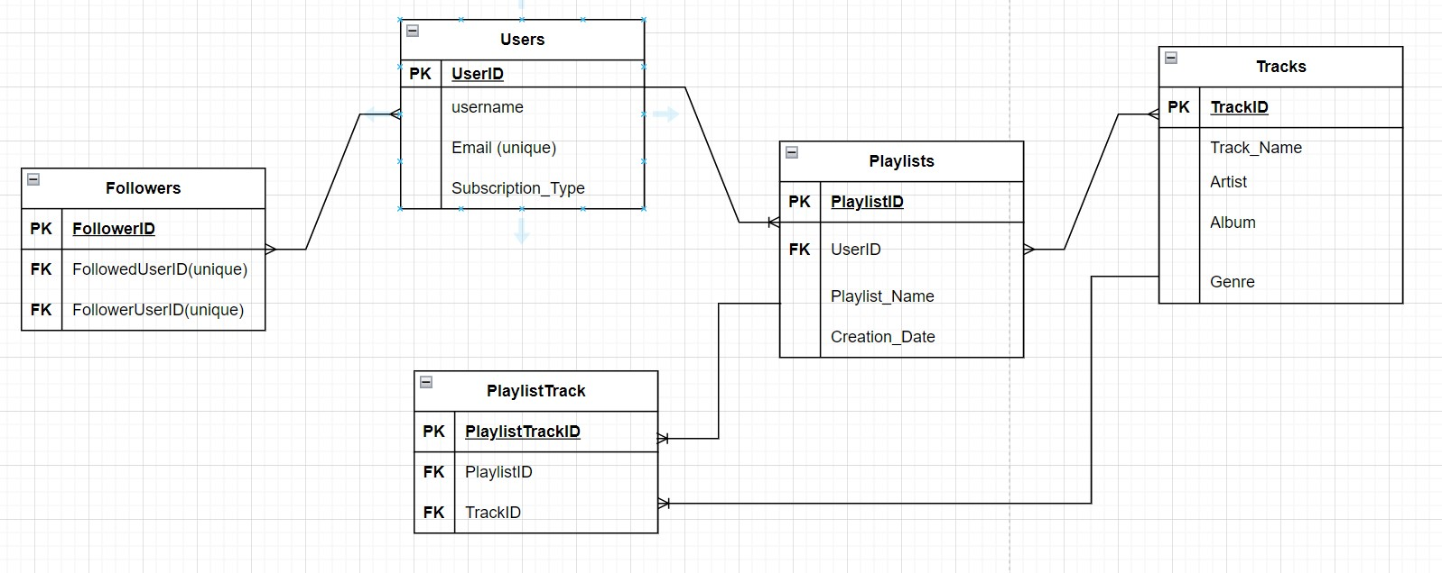

**Conclusion:**

Spotify’s success can be attributed to its user-centric approach to solving real-world problems in music discovery, social interaction, and content accessibility. The platform’s ability to deliver personalized experiences and foster connections through music has allowed it to become a dominant player in the streaming industry. The schema design captures the essential components of Spotify’s functionality, providing insight into how the platform handles large-scale data while keeping the user experience seamless.